B001v2 : The Fire Cross 1914-1918
The decoration was instituted on 6 February 1934 . It could not be awarded posthumously.
- the designer's name : A. Rombaut.
- Aprox value in 2013 : 12 to 14 euro
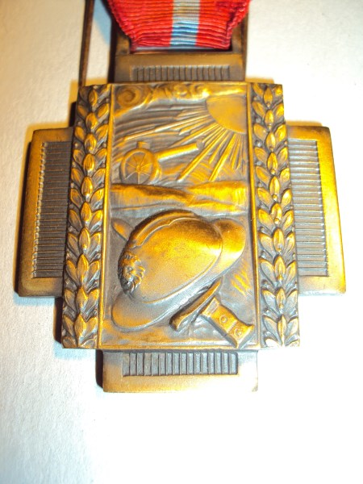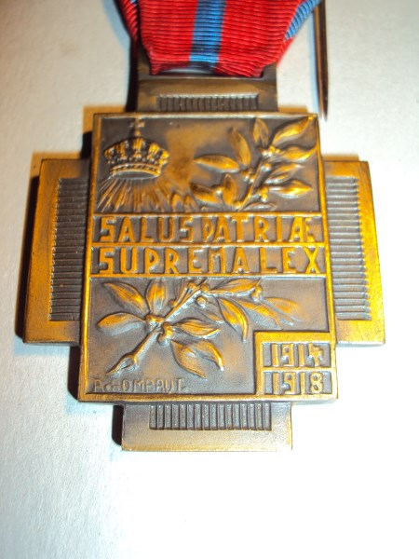
Special Identification :
