B001v5 : The Fire Cross 1914-1918
The decoration was instituted on 6 February 1934 . It could not be awarded posthumously.
- the designer's name : A. Rombaut.
- Aprox value in 2013 : 18 euro
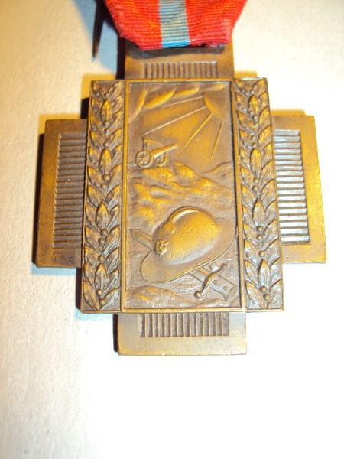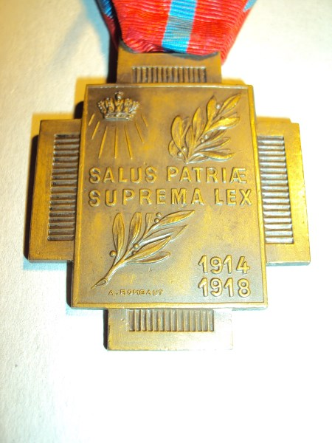
Special Identification :
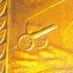 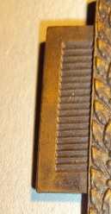21 mm high

